**ASSIGNMENT OF PYTHON SESSION #2**

Q. 1. What will be the value of the expression, 3 + 4 ** 6 – 9 * 10 / 2

Ans. The value of above expression is 4054. The precedence of operators (which are used in the given expression) is:

1. Exponentiation (**)
2. Multiplication (*) and Division (/)
3. Addition (+) and Subtraction (-)

If two operators of same precedence are given, they are evaluated from left to right. So, if we solve the given expression like we do in maths, it can be written as:

3 + 4 ** 6 – 9 * 10 / 2 = 3 + 4096 - 9 * 10 / 2

= 3 + 4096 – 90 / 2

= 3 + 4096 – 45

= 4099 – 45

= 4054

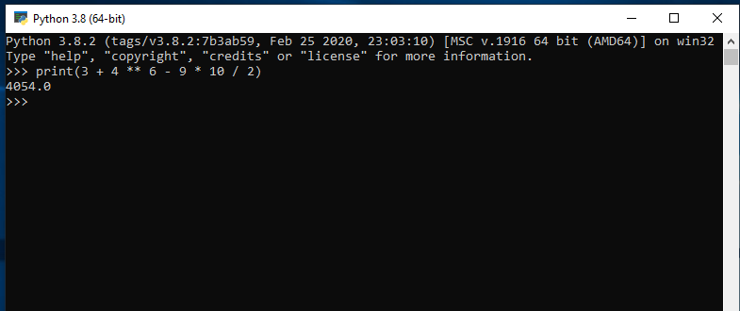

Q.2. A string is given “hello this side regex”. Find out the count of the total vowels.

Ans. 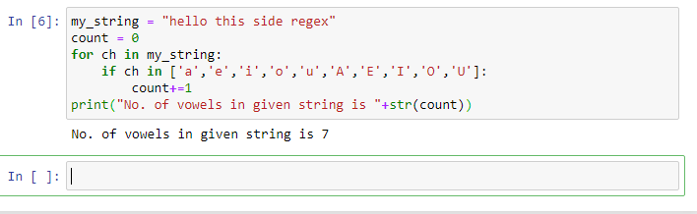

Q. 3. Find out the area of a triangle using the formula ½ * b * h. You have to take value of the base and height from the user.

Ans. 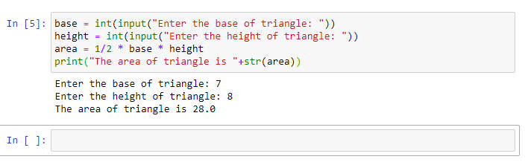

Q. 4. Print the calendar on the terminal for a given year. First allow the user to enter the year, then show the calendar of that year.

Ans. 